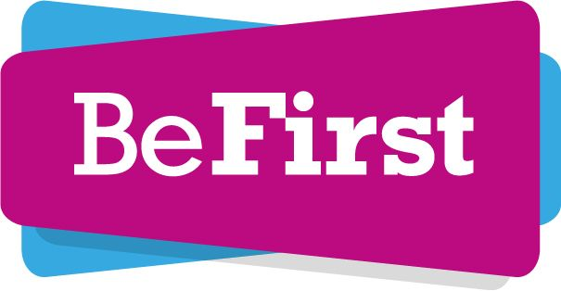

Job Description
Job Title: Community Engagement Coordinator
Salary: 35 – 40k plus benefits
Status of role: Permanent
Responsible to: Engagement Manager - Sadia Ur-Rehman
Purpose of the Job
Be First is a pioneering urban regeneration company wholly owned by Barking and Dagenham Council and operating independently. Our mission is to capitalise on the borough’s position as London’s best investment and development opportunity to accelerate growth. We aim to help deliver 50,000 new homes and 20,000 jobs in the next 20 years.
We deliver a socially-responsible model of urban regeneration that creates new homes and jobs for Barking and Dagenham’s current and future communities, ensuring that no-one is left behind.
We are firmly committed to community engagement and involvement as an essential element of our social purpose. This is an important position within Be First’s Engagement team and you will play a vital role in supporting us to embed high quality community involvement standards throughout the company.
The postholder will be responsible for:
- Strengthening the delivery of high-quality community engagement across Be First.
- Working across the organisation to build collaborative relationships and ensure a coordinated and cohesive approach to community engagement.
- Supporting with the on-going engagement activity across a number of major estate renewal projects aimed at building long term, open and transparent working relationships with the community to jointly deliver the objectives of the wider estate renewal programme.
- Support with developing the engagement strategies for these areas and the wider Be First programme.
- Manage our digital engagement platform.

Main responsibilities
  - To deliver innovative and coordinated engagement across the estate renewal schemes which maximises long term involvement in the regeneration programme and sets a new benchmark for reach, quality, and expertise.

  - Develop, manage, and deliver the engagement and consultation strategies for the local areas. This will include engagement on the delivery of the Be First programme and any emerging physical plans for change.

  - Support​ ​the​ ​team ​to​ ​build​ ​new​ ​and​ ​existing relationships​ ​and​ ​partnerships​ ​with​ ​organisations​ ​and​ ​key​ ​individuals​ ​across Barking & Dagenham.

  - Develop and maintain positive working relationships with the community and key stakeholder groups including residents, businesses, community groups.

  - Work across departments at LBBD and Be First to ensure engagement across the estate renewal areas is coordinated and integrated into Be First’s core engagement and communications activities.

  - Work with the Communications team to develop engagement material suitable for a variety of stakeholders. This will include newsletters, consultation material, leaflets, online and social media and will include arranging for translations.

  - Organise and manage engagement events with and for the community and key stakeholders.

  - Update and maintain our digital engagement platform.

  - Identify where additional engagement resource is required and manage additional resource for Be First.

  - Undertake a stakeholder mapping exercise, create a stakeholder database for individual projects and borough-wide initiatives and review and update regularly.

  - Produce an engagement and consultation log and report which records all engagement and consultation activity.

  - Manage and deliver statutory consultation processes for the allocated areas.

  - Support residents and stakeholders to develop and function effectively. This could include training and other capacity building that they may require to engage in various aspects of the programme.

1.14 Attendance at meetings/events in the evening and weekends as required.

Knowledge, Qualifications, Skills and Experience | Essential or Desirable
Demonstrable experience of delivering successful engagement with a wide range of complex stakeholders.  Experience of estate renewal and housing engagement.  Experience of evaluating and monitoring community involvement activity and community projects.  Experience of organising events and outreach activities  Experienced in developing engagement programmes and mechanisms that fully involve the community in developing plans for the future of their area.  Ability to champion community engagement within and without the company, and to ensure that consultation and involvement is meaningful and effective  Ability to engage, communicate effectively and understand the needs of a range of different community and project stakeholders.  Ability to work effectively with staff at all levels, work independently and as part of a team.  Ability to work in partnership with external agencies, including the council.  Ability to work across departments and services to deliver a coordinated engagement programme – including coordinating resources.  Experience of managing and being accountable for a project budget in a community engagement scheme.  Be resourceful, self-motivated, and able to work without supervision.  Qualifications  The post holder will ideally have a relevant degree or equivalent, although consideration will still be given to those applicants who are not qualified but who can demonstrate they have worked in engagement and/or regeneration for a significant length of time.  Knowledge/Skills  Knowledge of the legislative framework for consultation and engagement, and best practice.  Ability to balance competing workloads and deadlines.  Excellent communication skills, both verbal and written. Ability to communicate effectively with a range of audiences.  Excellent organisational skills.  Good attention to detail and ability to operate to tight deadlines in a highly pressurised environment.  Experience of utilising social media and digital platforms to engage a wider audience. | Essential  Desirable  Essential  Essential  Essential  Essential  Essential  Essential  Essential  Essential  Essential  Essential  Desirable  Essential  Essential  Essential  Essential  Essential  Essential

