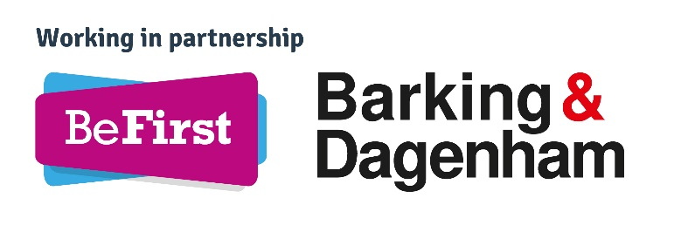
OVERVIEW OF JOB ROLE: Development Manager, Development Group
BACKGROUND
Be First is a pioneering urban regeneration company wholly owned by, but operating independently of, the London Borough of Barking and Dagenham (LBBD). Its mission is to accelerate growth and capitalise on the borough’s position as London’s hottest investment and development opportunity.
We are a developer and property consultancy, and provide planning and other statutory functions for LBBD. We also work with commercial partners who share our core values of delivering high quality development which benefits local people. The financial return that we generate is reinvested back into providing key council services.
The Development group is tasked with delivering many of Be First’s key business plan objectives. The Development Manager role will progress the delivery of a number of projects working in conjunction with a Construction Manager leading multi-disciplinary teams. A new and growing area of the Development team will be turnkey projects – purchasing schemes from third party developers. This role reports to the Head of Regeneration.
KEY REQUIREMENTS: DUTIES
Key responsibilities will be (but are not limited to):
- To contribute to the delivery of Be First’s development strategy (part of the Be First Business Plan) by working with a Construction Manager as part of multi-disciplinary project teams taking development schemes from inception to completion in line with project objectives and deadlines.

- To focus upon commercial delivery and company profitability through the effective delivery of Be First’s property & development initiatives especially focussing on turnkey schemes.

- To source, develop concept, secure all necessary approvals and deliver projects in line with the Be First Business Plan.

- Develop and maintain strong working relationships with key stakeholders. Ensure that all stakeholders are kept up to date with works progress, identify any aspects of the project which have significant potential to cause disputes or additional costs to be incurred and resolve as appropriate.

- Prepare and maintain project viability appraisals.

- Ensure programme activity remains to plan, is delivered on time and within agreed available resources.

- Ensure appropriate risk management and value for money considerations are in place to deliver agreed project outcomes and realisation of intended benefits.

- Assist in the development of effective procurement and contractual arrangements for schemes, appropriately managing risk and reward whilst complying with procurement regulations.

- Report effectively at designated reporting milestones on project delivery against budget and programme.

- Procuring, managing and monitoring a range of external consultants as part of multi-disciplinary teams.

- Demonstrate good commercial acumen and ability to generate profit from property related transaction, particularly development.

- To participate in Be First’s budgetary process, including monitoring expenditure against budget allocation and maintaining budgetary control at all times. Responsibility includes ensuring all fiscal activity accords with financial regulations and statutory requirements.

• Identify opportunities where further fees or income can be generated
KEY REQUIREMENTS: ATTRIBUTES
We are looking for an individual who:
Works well as part of a team – collaborative, problem solving and motivational. Strong numeracy/financial appraisal skills. Confident and professional, with excellent communication skills – able to present (verbally and in writing) to different audiences succinctly outlining proposals and business cases. Proactive self-starter who takes the initiative, can prioritise and find solutions. IT literate.
JOB SALARY
Grade 5 £42,278.34 to £63,418.55 plus company benefits including pension and eligibility for performance related bonus.
Please submit a covering letter and CV to david.harley@befirst.London by February 26 2021

